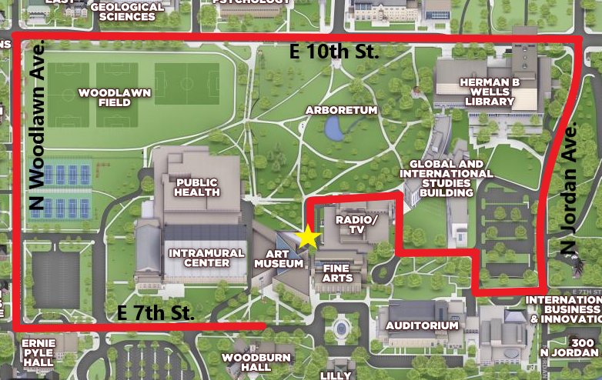

From Art Museum Main Entrance:
- Take 7th St. back to Woodlawn Ave.
- Turn right at Woodlawn Ave past the parking attendant.
- Turn right on 10th St.
- Turn right on Jordan Ave.
- Turn right at the stop sign at 7th St.
- Turn right into the Wells Library parking lot. Take the first left past the Global and International Studies and Fine Arts buildings. Follow the road around the Radio/TV Building until you reach the Museum Mezzanine entrance.

